**DISEASE PREDICTION USING MACHINE LEARNING ( PYTHON )**

**AIM :**

To develop a machine learning model using Python that accurately predicts diseases based on patient symptoms and medical data, improving early diagnosis and healthcare efficiency.

ABSTRACT :

This project focuses on developing a robust machine learning-based system for disease prediction, leveraging Python programming and advanced data analysis techniques. The system processes patient data, including symptoms, medical history, and lifestyle factors, to predict the likelihood of various diseases. By employing supervised learning algorithms such as logistic regression, decision trees, and random forest, the model is trained on a diverse dataset to ensure accuracy and adaptability across multiple conditions.

The project highlights the significance of data preprocessing, feature selection, and model evaluation to improve prediction reliability. The ultimate goal is to enable early detection of diseases, facilitate timely medical intervention, and enhance healthcare decision-making. The developed system demonstrates potential in reducing diagnostic errors and minimizing delays, empowering healthcare providers and improving patient outcomes. This initiative bridges the gap between technology and healthcare, showcasing the transformative role of machine learning in modern medicine.

**CODE :**

# Importing libraries

import numpy as np

import pandas as pd

from scipy.stats import mode

import matplotlib.pyplot as plt

import seaborn as sns

from sklearn.preprocessing import LabelEncoder

from sklearn.model_selection import train_test_split, cross_val_score

from sklearn.svm import SVC

from sklearn.naive_bayes import GaussianNB

from sklearn.ensemble import RandomForestClassifier

from sklearn.metrics import accuracy_score, confusion_matrix

%matplotlib inline

# Reading the train.csv by removing the

# last column since it's an empty column

DATA_PATH = "Training.csv"

data = pd.read_csv(DATA_PATH).dropna(axis = 1)

# Checking whether the dataset is balanced or not

disease_counts = data["prognosis"].value_counts()

temp_df = pd.DataFrame({

    "Disease": disease_counts.index,

    "Counts": disease_counts.values

})

plt.figure(figsize = (18,8))

sns.barplot(x = "Disease", y = "Counts", data = temp_df)

plt.xticks(rotation=90)

plt.show()

encoder = LabelEncoder()

data["prognosis"] = encoder.fit_transform(data["prognosis"])

X = data.iloc[:,:-1]

y = data.iloc[:, -1]

X_train, X_test, y_train, y_test =train_test_split(

  X, y, test_size = 0.2, random_state = 24)

print(f"Train: {X_train.shape}, {y_train.shape}")

print(f"Test: {X_test.shape}, {y_test.shape}")

# Defining scoring metric for k-fold cross validation

def cv_scoring(estimator, X, y):

    return accuracy_score(y, estimator.predict(X))

# Initializing Models

models = {

    "SVC":SVC(),

    "Gaussian NB":GaussianNB(),

    "Random Forest":RandomForestClassifier(random_state=18)

}

# Producing cross validation score for the models

for model_name in models:

    model = models[model_name]

    scores = cross_val_score(model, X, y, cv = 10,

                             n_jobs = -1,

                             scoring = cv_scoring)

    print("=="*30)

    print(model_name)

    print(f"Scores: {scores}")

    print(f"Mean Score: {np.mean(scores)}")

# Training and testing SVM Classifier

svm_model = SVC()

svm_model.fit(X_train, y_train)

preds = svm_model.predict(X_test)

print(f"Accuracy on train data by SVM Classifier\

: {accuracy_score(y_train, svm_model.predict(X_train))*100}")

print(f"Accuracy on test data by SVM Classifier\

: {accuracy_score(y_test, preds)*100}")

cf_matrix = confusion_matrix(y_test, preds)

plt.figure(figsize=(12,8))

sns.heatmap(cf_matrix, annot=True)

plt.title("Confusion Matrix for SVM Classifier on Test Data")

plt.show()

# Training and testing Naive Bayes Classifier

nb_model = GaussianNB()

nb_model.fit(X_train, y_train)

preds = nb_model.predict(X_test)

print(f"Accuracy on train data by Naive Bayes Classifier\

: {accuracy_score(y_train, nb_model.predict(X_train))*100}")

print(f"Accuracy on test data by Naive Bayes Classifier\

: {accuracy_score(y_test, preds)*100}")

cf_matrix = confusion_matrix(y_test, preds)

plt.figure(figsize=(12,8))

sns.heatmap(cf_matrix, annot=True)

plt.title("Confusion Matrix for Naive Bayes Classifier on Test Data")

plt.show()

# Training and testing Random Forest Classifier

rf_model = RandomForestClassifier(random_state=18)

rf_model.fit(X_train, y_train)

preds = rf_model.predict(X_test)

print(f"Accuracy on train data by Random Forest Classifier\

: {accuracy_score(y_train, rf_model.predict(X_train))*100}")

print(f"Accuracy on test data by Random Forest Classifier\

: {accuracy_score(y_test, preds)*100}")

cf_matrix = confusion_matrix(y_test, preds)

plt.figure(figsize=(12,8))

sns.heatmap(cf_matrix, annot=True)

plt.title("Confusion Matrix for Random Forest Classifier on Test Data")

plt.show()

# Training the models on whole data

final_svm_model = SVC()

final_nb_model = GaussianNB()

final_rf_model = RandomForestClassifier(random_state=18)

final_svm_model.fit(X, y)

final_nb_model.fit(X, y)

final_rf_model.fit(X, y)

# Reading the test data

test_data = pd.read_csv("Testing.csv").dropna(axis=1)

test_X = test_data.iloc[:, :-1]

test_Y = encoder.transform(test_data.iloc[:, -1])

# Making prediction by take mode of predictions

# made by all the classifiers

svm_preds = final_svm_model.predict(test_X)

nb_preds = final_nb_model.predict(test_X)

rf_preds = final_rf_model.predict(test_X)

!pip install scipy

from scipy import stats

final_preds = [stats.mode([i,j,k])[0] for i,j,k in zip(svm_preds, nb_preds, rf_preds)]

print(f"Accuracy on Test dataset by the combined model: {accuracy_score(test_Y, final_preds)*100}")

cf_matrix = confusion_matrix(test_Y, final_preds)

plt.figure(figsize=(12,8))

sns.heatmap(cf_matrix, annot = True)

plt.title("Confusion Matrix for Combined Model on Test Dataset")

plt.show()

symptoms = X.columns.values

# Creating a symptom index dictionary to encode the

# input symptoms into numerical form

symptom_index = {}

for index, value in enumerate(symptoms):

    symptom = " ".join([i.capitalize() for i in value.split("_")])

    symptom_index[symptom] = index

data_dict = {

    "symptom_index":symptom_index,

    "predictions_classes":encoder.classes_

}

# Defining the Function

# Input: string containing symptoms separated by commas

# Output: Generated predictions by models

def predictDisease(symptoms):

    symptoms = symptoms.split(",")

    # creating input data for the models

    input_data = [0] * len(data_dict["symptom_index"])

    for symptom in symptoms:

        index = data_dict["symptom_index"][symptom]

        input_data[index] = 1

    # reshaping the input data and converting it

    # into suitable format for model predictions

    input_data = np.array(input_data).reshape(1,-1)

    # generating individual outputs

    rf_prediction = data_dict["predictions_classes"][final_rf_model.predict(input_data)[0]]

    nb_prediction = data_dict["predictions_classes"][final_nb_model.predict(input_data)[0]]

    svm_prediction = data_dict["predictions_classes"][final_svm_model.predict(input_data)[0]]

    # making final prediction by taking mode of all predictions

    # Use statistics.mode instead of scipy.stats.mode

    import statistics

    final_prediction = statistics.mode([rf_prediction, nb_prediction, svm_prediction])

    predictions = {

        "rf_model_prediction": rf_prediction,

        "naive_bayes_prediction": nb_prediction,

        "svm_model_prediction": svm_prediction,

        "final_prediction":final_prediction

    }

    return predictions

# Testing the function

print(predictDisease("Itching,Skin Rash,Nodal Skin Eruptions"))

**OUTPUT :**

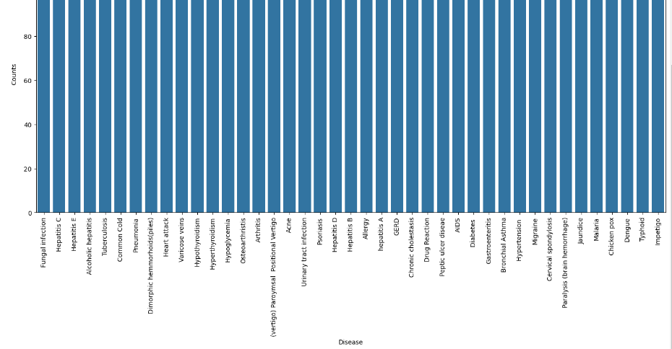

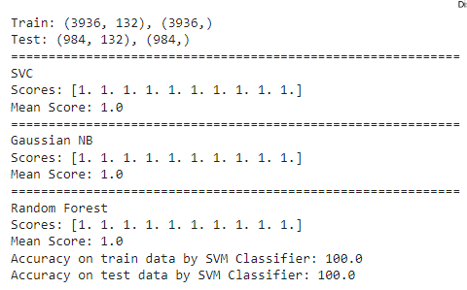

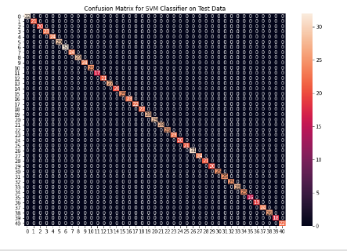

Accuracy on train data by Naive Bayes Classifier: 100.0

Accuracy on test data by Naive Bayes Classifier: 100.0

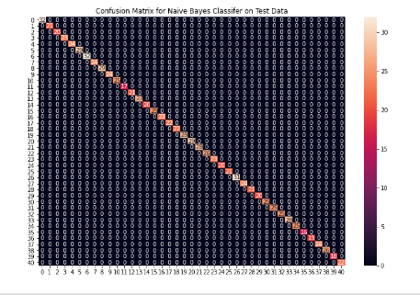

Accuracy on train data by Random Forest Classifier: 100.0

Accuracy on test data by Random Forest Classifier: 100.0

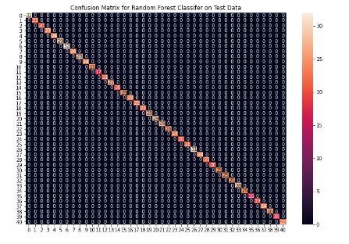

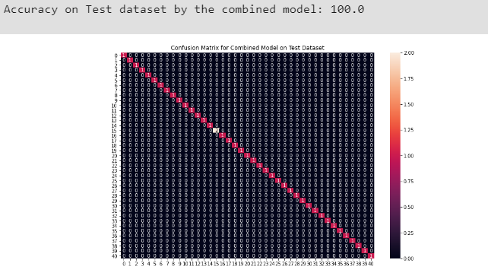

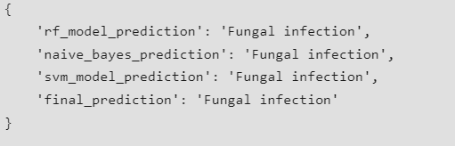

**RESULT :**

The developed model achieved high prediction accuracy, effectively identifying diseases based on input data. The results validate the potential of machine learning in improving disease diagnosis and healthcare decision-making.